Exercise 1 – Map Analysis Framework (MapCalc) Spatial Analysis

Exercise 2 – Reclassify and Overlay (MapCalc) Spatial Analysis

Access the MapCalc software system by double-clicking its icon on the desktop or pressing Start→ Programs→ Red Hen Systems→ MapCalc→ MapCalc
Select the Tutor25.rgs data base.

Generate the following displays of the Elevation surface…(remember how?)

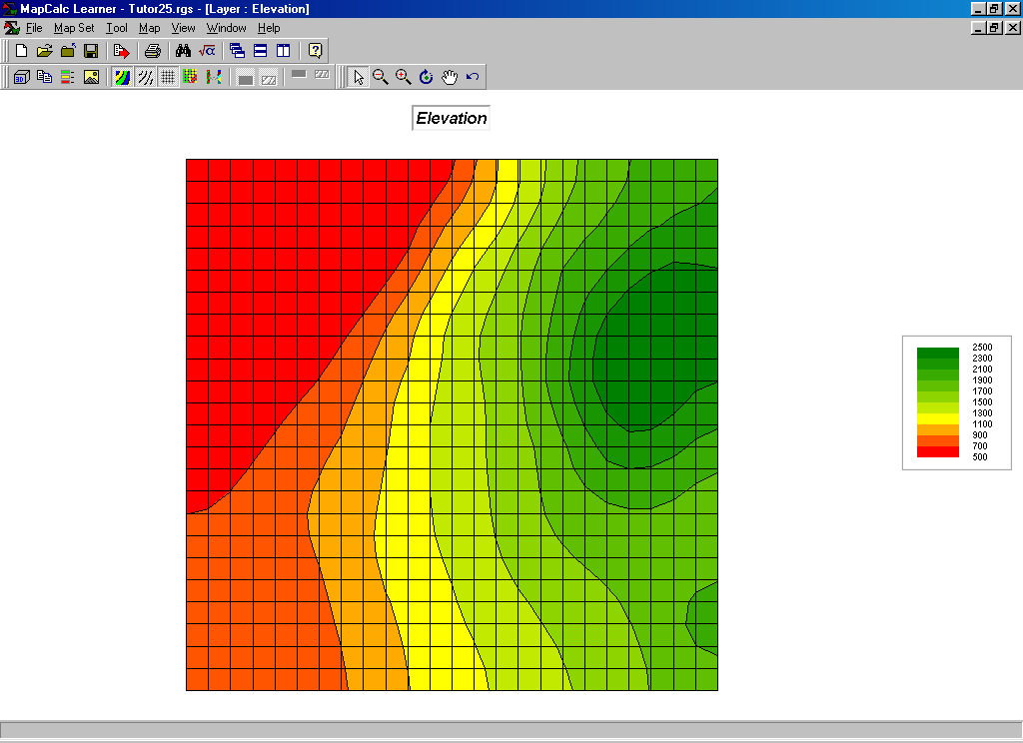 2D Contour map display with analysis grid

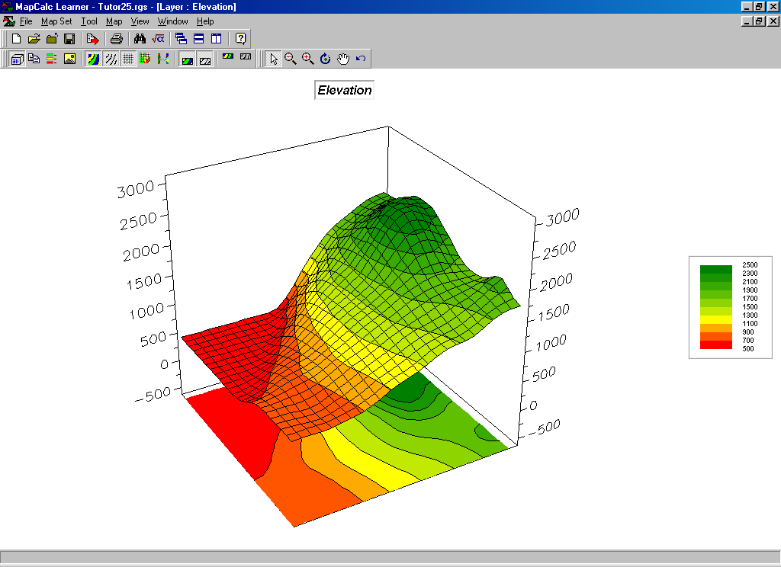 3D Wireframe display

Derive a maps of terrain steepness (Slopemap) and terrain orientation (Aspectmap) by…

Press the Map Analysis button to pop-up the Map Analysis dialog box.
Select Neighbors→ Slope to pop-up the Slope dialog box. Complete the form as shown below.

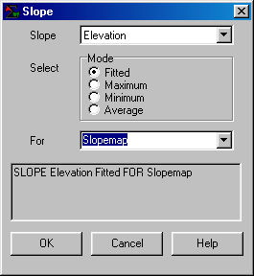 …what is the percent slope of the steepest location? Where is it?

Re-display the Elevation map (Window→ Elevation) then select Map→ Overlay→ Slopemap to “drape” the slopemap over the terrain surface and note the alignment of the two maps.

Press the Map Analysis button to pop-up the Map Analysis dialog box.
Select Neighbors→ Orient to pop-up the Orient dialog box. Complete the form as shown below.

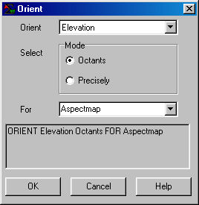 …what is the aspect of the steepest location? Drape the Aspectmap over the Elevation surface

Press the Map Analysis button to pop-up the Map Analysis dialog box.
On the Map Analysis menu click on Scripts→ Open→ navigate to the …\Scripts folder → select Habitat.scr file.

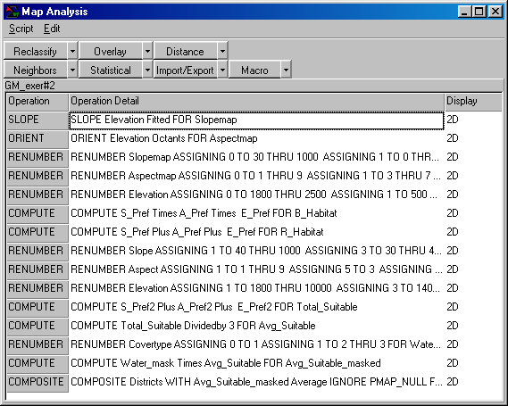 Habitat.scr script

You completed the first two command lines…
SLOPE Elevation Fitted FOR Slopemap
ORIENT Elevation Octants FOR Aspectmap
…in the previous section.

Double-click on the next command line…
RENUMBER Slopemap ASSIGNING 0 TO 30 THRU 1000
ASSIGNING 1 TO 0 THRU 30 FOR S_Pref
…to pop-up the Renumber dialog box for this step of the habitat command macro.

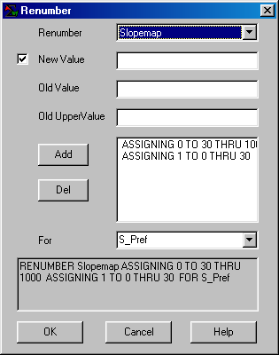 RENUMBER Slopemap assigning… dialog box

Repeat for each of the successive command lines to complete the model. Referring to the flowchart of the simple Habitat model, describe the processing and the resultant maps.

Under the guidance of the instructor, sketch a flowchart of the processing using boxes as maps and lines as analysis operations.

Exercise 3 – Distance and Neighbors (MapCalc) Spatial Analysis

Homework Exercise – Campground Suitability Model (MapCalc)

